**Setting Up the PowerTeacher Pro Gradebook**

**Step 1:**

**Setting up Grade Categories (Homework, Quizzes, etc…)**

On the left sidebar, click on Grading 🡪 Categories

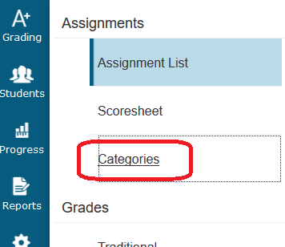

The default setup should look something like this:

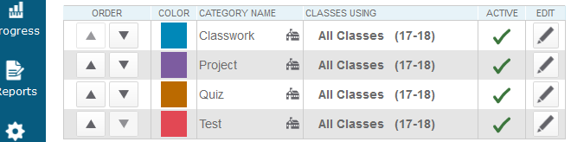

Put in whatever categories you will need. I added: “Homework” and “Other”

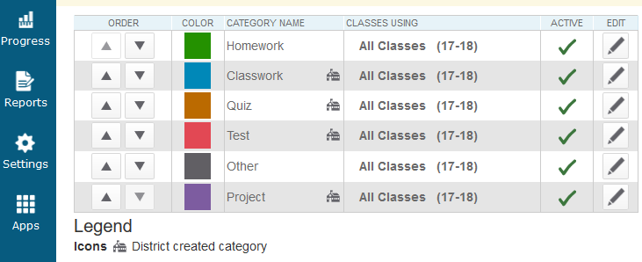

The four pre-existing categories (Classwork, Quiz, Test, and Project) cannot be changed. But they can be rearranged. Put your most frequently used category at the top.

**Step2:**

**Setting up Terms (Y1, S1, T1, Q1, etc…)**

Here is a time diagram of S1:

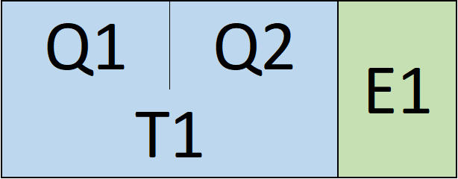

S1 is a time period that has many smaller time periods within it. T1 can either be built off of the quarters or just directly through entering grades. In ISQ secondary, we do NOT use quarter grades to calculate final grades.

On the left sidebar of the gradebook, click on Settings 🡪 Traditional Grade Calculations

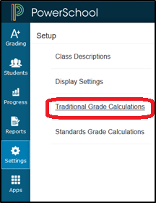

Start with S1 by clicking on the pen icon.

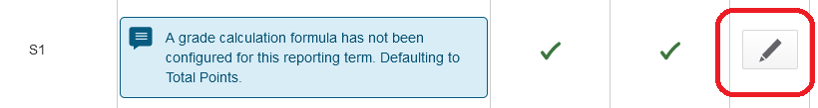

**Classes with a 20% Final (Nearly[1] all HS classes. No MS classes.)**

**Setting up S1:**

Go to S1 and set it up with the Final exam counting as 20% of the overall grade.[2]

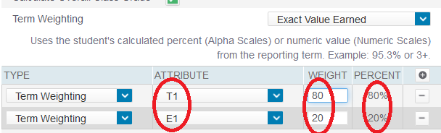

Next set up T1, which refers to all the regular scores (everything except the final).

If you are using weighted categories, yours will look something like this[3] (these are the categories that the Math Department uses):

If you are not using category weights, you should be able to leave T1 as it is (but make sure to press save):

Next, move on to Q1 and Q2. We do not use them at all, so they need to be turned off[4]. Go into Q1 and Q2 and ***UNCHECK*** the box that says “Calculate Overall Class Grade.”

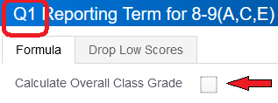

Then, when students look at their Q1/Q2 grades, they will merely appear blank. This is fitting and appropriate since they do not actually have quarter grades. Here is what a student’s grades might look like when they check them:

Lastly, set up E1. This represents the final exam score. If your final is just a regular test or presentation, then just leave it as “total points” and hit save:

You’re done with S1! Everything for 2nd semester is similar. If your class is year-long, go ahead and set it up now! 😊

**Classes *without* a 20% Final (All MS classes. HS classes only with approval.)**

**Setting up S1:**

Go to S1 and set it up as either total points or category weighting. For category weighting, see the “T1” instructions in the section above.)

After setting up S1, you should “turn off” all of T1, Q1, Q2, and E1. This is because if there is no 20% final, then S1 is calculated directly, rather than from averaging grades from smaller time periods. Go into each of T1, Q1, Q2, and E1, and ***UNCHECK*** “Calculate Overall Class Grade.”



You’re done with S1! Everything for 2nd semester is similar. If your class is year-long, go ahead and set it up now! 😊

Once you have everything set up for one class for the whole year, you can copy that setup to other classes where you want the same grading scheme, by going to the top, clicking the gear icon, and selecting “Copy Traditional Grade Calculations.”

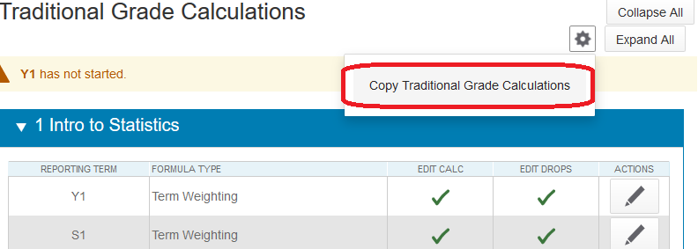

Pick the Term and Class name of the class that you already set up. Then choose the classes to which you wish to copy it.

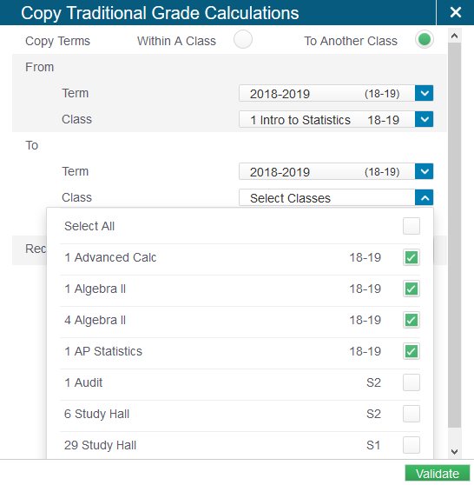

**Step 3:**

**Correct Date for a 20% Final Exam**

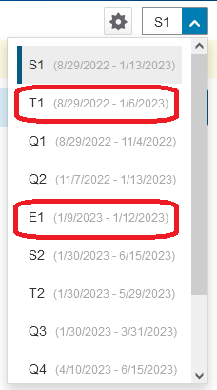

If you give a 20% final exam, it MUST be placed during E1 in the gradebook, **even if you give it early**. For Fall 2022, this is from Jan 9-12. Nothing else should be placed in this period. All regular grades should be during the T1 period for them to be counted as part of T1 (for Fall 2022: Aug 29 - Jan 6). It might be a good idea to go ahead and create your final exam item in the gradebook now, so that you don’t have to remember this in January.

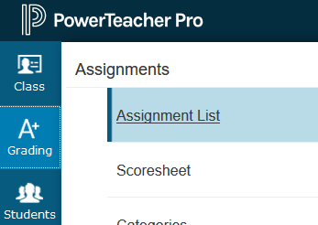1. On the left, click on Grading 🡪 Assignment List to see all your assignments.

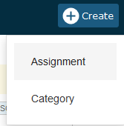

2. At the top, click on   
Create 🡪 Assignment

3. Enter the assignment details. Most importantly, list it as being during the correct date range of E1, ***even if you are giving your final early.***

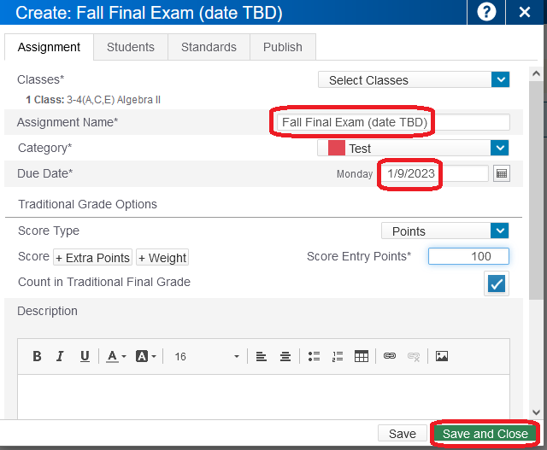

You might need to change this $±$ a few days when the final exam schedule comes out.

**In middle school classes that have a final**, the final exam should count as two test grades. Therefore, it should be weighted double. Here is one way:



1. On the left, click on Grading 🡪 Assignment List to see all your assignments.



2. At the top, click on   
  
Create 🡪 Assignment

3. Click on +Weight 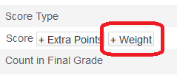

4. Enter a weight of 2. 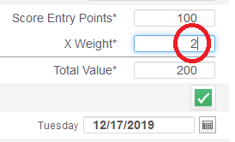

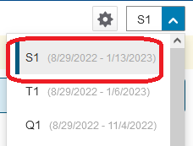

5. Set a date near the end of the term. You can change this $±$ a few days when you know the actual date for your final. Since your S1 is not calculated based on T1 and E1, you don’t have to worry about making sure it is in one or the other. Just make sure it is in the S1 time period.

**Entering Comments**

***WHAT* to Write:**

Principals will typically send out guidelines for writing comments.

***HOW* to Enter Comments:**

First, click on the grading tab to open the options then click on Comment Verification.

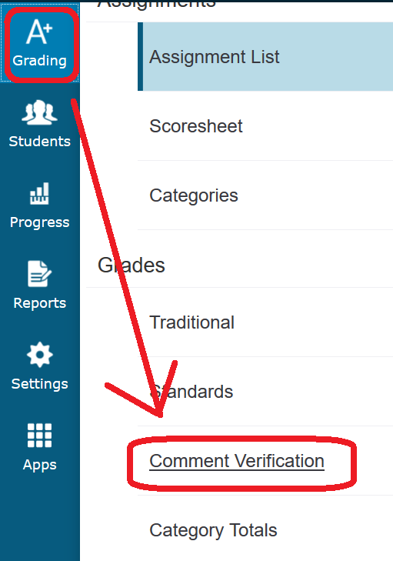

Once that page opens, verify that it says S1 (or S2 for second semester) at the top.

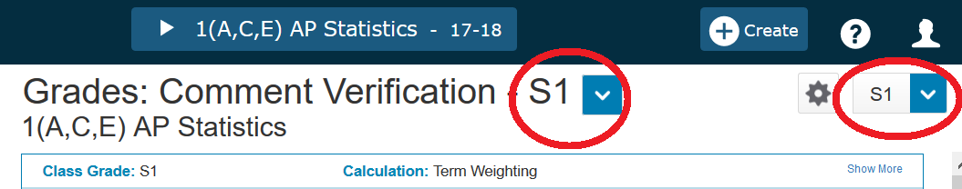

Then click on the grade column, which is the space to the right of the students’ names. This will bring up the side bar on the right. Scroll down to the comment box at the bottom and input your comment. Make sure to click the green save button at the bottom or it will disappear once you leave the page.

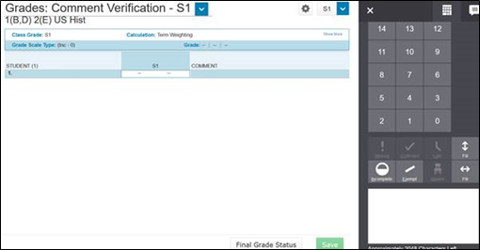

Pro Tip: Write all your comments in another program, such as Word. Then copy-paste them into the comment section. This way, you can easily see what you wrote for that student in previous comments.

1. You should have express permission from your HOD or the principal to set up your HS class as not having a 20% final.
2. For weighs, you can enter, 80/20 or 8/2, or 4/1 or 8000/2000, or anything else that will represent the same ratio.
3. If you don’t see the categories that you created before, it might have something to do with who the “lead teacher” is. Did you inherit the course from someone who taught it last year? Are you team teaching with someone else? If this is the issue, either go to that person or to a PowerSchool Administrator.
4. Why? – Since elementary uses quarter grades, our PowerSchool has them too. Without intentional adjustment, PowerSchool will show students a Q1 grade that might not match with their S1 grade. Even worse, students might see an 80% for Q1 and a 70% for Q2 and may expect to get a 75% for the term (before the final), but this is not right, since their T1 grade is count ed simply as one long term. If there were twice as many points offered in Q2, then their true grade will be lower than 75%.